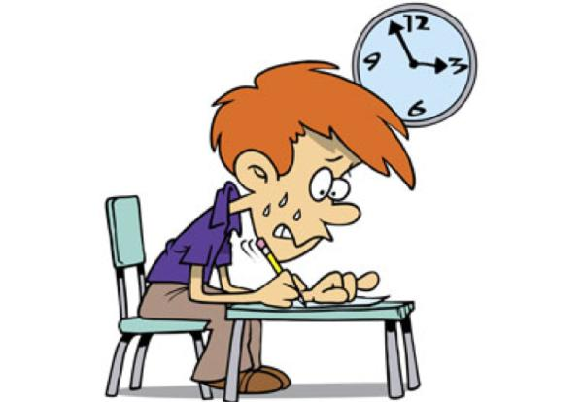COMP251 FALL 2023 TEST ONE OCTOBER 31, 2023

You have 2 hours to complete the test! Good luck!

NAME: __Tori Thompson_________________________________ ____/30

TRUE OR FALSE (10 marks)

1. The redefines clause assigns another name to previously allocated space. T F
2. SEARCH ALL denotes a binary search. T F
3. A SEARCH statement can contain only a single WHEN clause. T F
4. An index cannot be manipulated by a MOVE command. T F
5. The SEARCH statement requires an index. T F
6. A SUBSCRIPT of zero refers to the first element in a table. T F
7. Instead of defining each field separately, a table defines a field with ONE name, but uses OCCURS clause to repeat the definition. T F
8. You cannot use an occurs clause on an 01 data item. T F
9. When using INDEXES, you need to create the index as a variable separate from the table. T F
10. The PERFORM VARYING statement may manipulate both subscripts and indexes. T F

SHORT ANSWER

1. Given the COBOL definition:
2. W01-CORPORATION

05 W01-REGION OCCURS 4 TIMES

10 W01-STATE OCCURS 5 TIMES PIC X(10)

How many elements are present in the table? _____20____________ (3 marks)

Any reference to W01-REGION requires how many subscripts? ___1_________ ( 1 mark)

Any reference to W01-STATE requires how many subscripts? _____2________ ( 1 mark)

Any reference to W01-CORPORATION requires how many subscripts? ___0__________ ( 1 mark)

(1 mark) Is the subscript …

1. part of the table
2. defined on its own in Working Storage
3. What are the **terminators** for the following statements (7 marks)
   1. READ __END-READ______________________________________
   2. SEARCH ___END-SEARCH_________________________________
   3. PERFORM VARYING __END-PERFORM________________________
   4. EVALUATE _END-EVALUATE________________________________
   5. COMPUTE __END-COMPUTE_______________________________
   6. IF __END-IF_____________________________________________
   7. SEARCH ALL __END-SEARCH________________________________
4. (2 marks)

Give 2 commands that can be used to **modify** an INDEX?

_____SET OR PERFORM VARYING____________________________________

1. (4 marks) Give 2 differences between a **SUBSCRIPT** and an **INDEX**
2. Search all controls the value of the table INDEX, whereas with subscript you have to define its value.
3. You don’t create an index as a separate variable, you provide the name with the occurs, whereas with subscript you need to define this variable.
4. (Bonus question) What does **COBOL** stand for?

__COmmon Business-Oriented Language___________________________